**EXPERIMENT – 8**

**TITLE: Strings Handling and Wrapper Class**

1. **Write a program for searching strings for the first occurrence of a character or substring and for the last occurrence of a character or substring.**

import java.util.Scanner;

class occur{

public static void main(String agrs[]){

Scanner sc=new Scanner(System.in);

String str;

System.out.println("Enter a String");

str=sc.nextLine();

char ch;

System.out.println("Enter a Character to be searched");

ch=sc.next().charAt(0);

int firstIndex=str.indexOf(ch);

System.out.println("First occurance at position:" + firstIndex);

int lastIndex=str.lastIndexOf(ch); System.out.println("Last occurance at position:" + lastIndex); }

}

**2) Write a program that converts all characters of a string in capital letters. (Use StringBuffer to store a string). Don’t use inbuilt function.**

import java.util.Scanner;

class upper{

public static void main(String args[]){

Scanner sc=new Scanner(System.in);

System.out.println("Enter a string");

StringBuffer stringbuffer=new StringBuffer();

stringbuffer.append(sc.nextLine());

System.out.println("You entered string:" + " " +stringbuffer);

String upp=new String();

for (int i = 0; i< stringbuffer.length(); i++){

char aChar = stringbuffer.charAt(i);

if (97 <= aChar && aChar<=122){

aChar = (char)( (aChar -32) );

upp=upp+aChar;

}

}

System.out.println("In upper case:" +" " +upp);

}

}

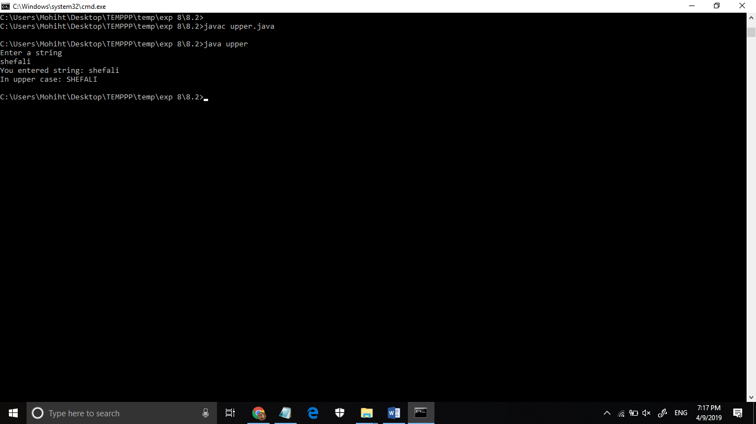

**3) Write a program in Java to read a statement from console, convert it into upper case and again print on console. (Don’t use inbuilt function)**

import java.util.Scanner;

class upper{

public static void main(String args[]){

Scanner sc=new Scanner(System.in);

System.out.println("Enter a string");

StringBuffer stringbuffer=new StringBuffer();

stringbuffer.append(sc.nextLine());

System.out.println("You entered string:" + " " +stringbuffer);

String upp=new String();

for (int i = 0; i< stringbuffer.length(); i++){

char aChar = stringbuffer.charAt(i);

if (97 <= aChar && aChar<=122){

aChar = (char)( (aChar -32) );

upp=upp+aChar;

}

}

System.out.println("In upper case:" +" " +upp);

}

}



**4) Write a program in Java to create a String object. Initialize this object with your name. Find the length of your name using the appropriate String method. Find whether the**

**character ‘a’ is in your name or not; if yes find the number of times ‘a’ appears in your name. Print locations of occurrences of ‘a’ .Try the same for different String objects**

import java.util.Scanner;

class A{

public static void main(String args[]){

Scanner sc= new Scanner(System.in);

String str= new String();

str= "Shefali";

int len=str.length();

int count=0;

System.out.println("lenght of your name is" + len);

for(int i=0; i<str.length();i++){

if(str.charAt(i)=='a'||str.charAt(i)=='A'){

count++;

System.out.println(" a or A found at " + i +"th position");

}

}

System.out.println(" a found at " + count +"times");

}

}

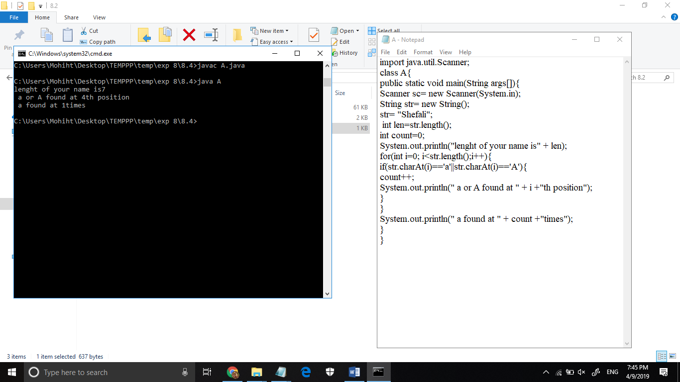

**TITLE: Wrapper Classes**

* **Write a Java code that converts int to Integer, converts Integer to String, converts String to int, converts int to String, converts String to Integer converts Integer to int.**

import java.util.Scanner;

class convert{

public static void main(String args[]){

//int to Integer

int a=20;

Integer i1 =Integer.valueOf(a); //converting int into Integer

Integer j=a; //autoboxing, now compiler will write Integer.valueOf(a) internally.

System.out.println(j);

//Integer to int

Integer a1=new Integer(3);

int i2=a1.intValue();//converting Integer to int

int j1=a1;//unboxing, now compiler will write a.intValue() internally

System.out.println(j);

//int to String

int c = 134;

String str3 = String.valueOf(c);

System.out.println(str3);

//String to int

String number = "10";

int result = Integer.parseInt(number);

System.out.println(result);

//String to Integer using integer.parseint

String s1 = "2015";

int i3 = Integer.parseInt(s1);

System.out.println(i3);

//String to Integer using valueOf()

String s3 = "2015";

int i4= Integer.valueOf(s3);

System.out.println(i4);

//Integer to string

int i5 = 2015;

String s = Integer.toString(i4);

System.out.println(s);

}

}

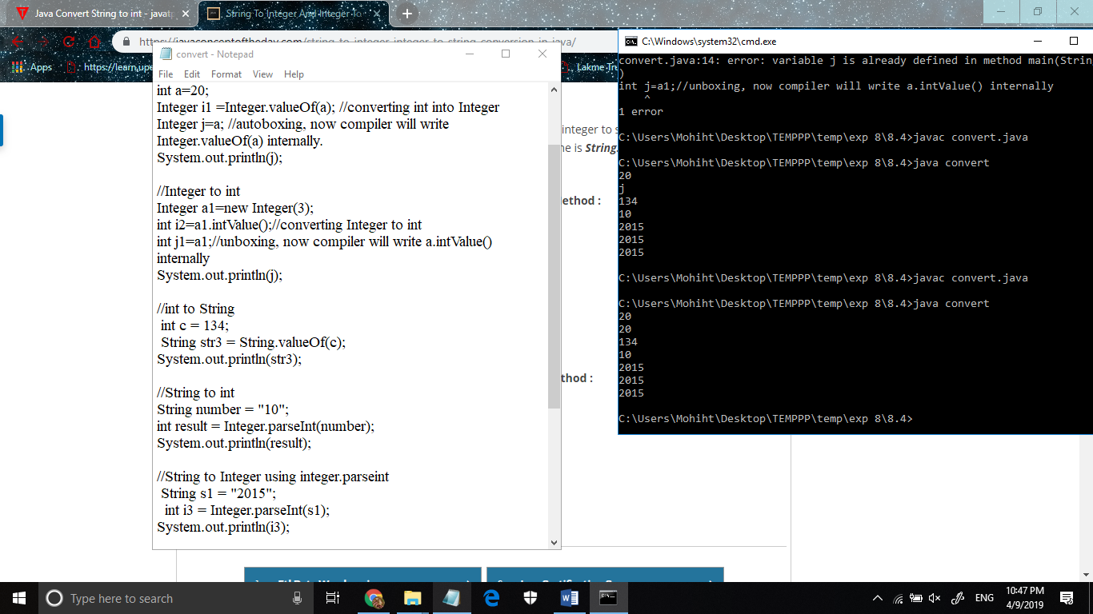

* **Write a Java code that converts float to Float converts Float to String converts String to float converts float to String converts String to Float converts Float to float.**

import java.util.Scanner;

class convert2{

public static void main(String args[]){

//converts float to Float

float f1=20;

//1st way

Float F1= new Float(f1);

System.out.println(F1);

//2rd way

Float F3=Float.valueOf(f1);

System.out.println(F3);

//converts Float to String

//1st way

Float F4= new Float(30);

String str1=F4.toString();

System.out.println(str1);

//2nd way

String str2= String.valueOf(F4);

System.out.println(str2);

//3rd way

String str3=" "+F4;

System.out.println(str2);

//converts String to float

String s2="20.3";

float f2= Float.parseFloat(s2);

System.out.println(f2);

//convert float to String

float f3= 12.3f;

String s3=String.valueOf(f3);

System.out.println(f3);

//convert String to Float

String s="20.4";

//1st way

Float F5 = new Float(s);

System.out.println(F5);

//2nd way

Float F8=Float.valueOf(s);

System.out.println(F8);

//3rd way

Float F9=Float.parseFloat(s);

System.out.println(F9);

//convert Float to float

Float F7= new Float(20.7f);

float f4= F7.floatValue();

System.out.println(f4);

}

}

